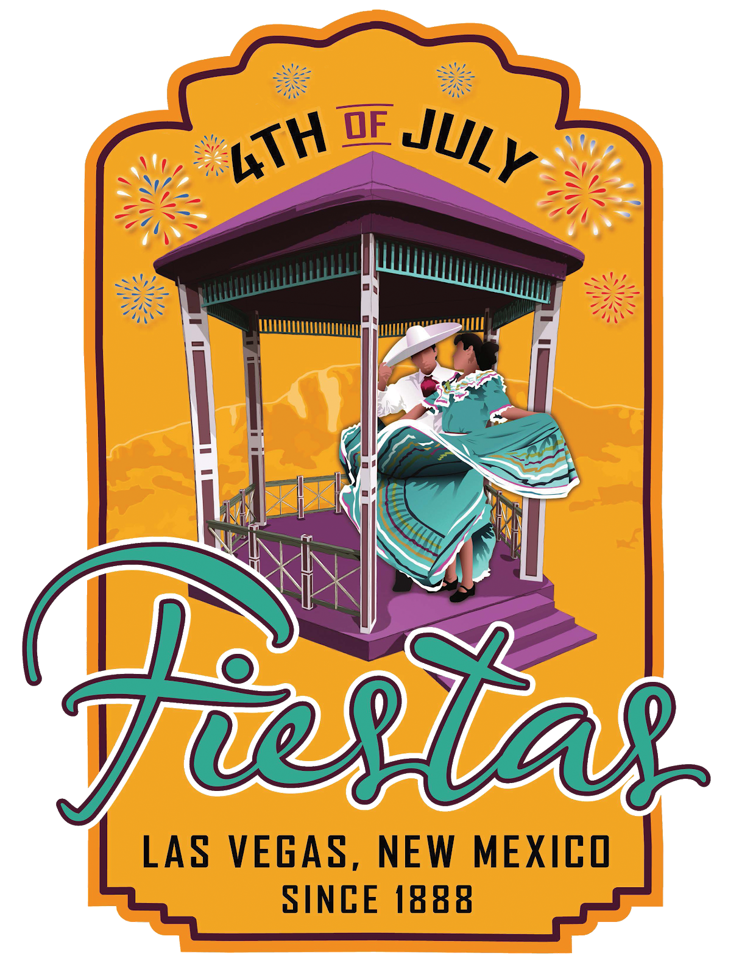FIESTAS ROYALTY APPLICATION FORM
4th of July Fiestas 2023
Theme: RECUERDOS DE CULTURA
------------------------------------------------------------------------------------------
Return to:
City of Las Vegas /Las Vegas 4th of July Fiestas
Attn: Charles Griego
500 Grand Avenue
Las Vegas, NM 87701 505-454-1401

Application Due Date: Thursday, May 26, 2023 by 5:00 PM

Point of Contact: Charles R. Griego at (505) 454-1401 ext 1604

The following must be included with this application:

- Essay 250 words submitted in English (Why I would like to be Las Vegas Royalty.).
- Three letters of reference from non-family members.
- 8X10 Color Photo

GENERAL INFORMATION

Name:

Mailing Address:

Contact Phone #:
Secondary Contact Phone #:

Email Address:
Marital Status:

Date of Birth:
Place of Birth:

Employer and/or School:

Mother’s Name:
Father’s Name:

Parent’s Address:
Parent’s Address:

Parent’s Phone #:
Parent’s Secondary Phone #:

ROYALTY GUIDELINES

- Must be interested in the 4th of July Fiestas and in portraying the role of Las Vegas Royalty, for one (1) year from the date of selection as Las Vegas Royalty until a successor has been named.
- Candidates must be between the ages of 17 and 20 years of age.

- Candidates must be a resident of San Miguel County.

- Candidates must be able to communicate effectively while representing the city of Las Vegas and must be willing to do so at Pre-Fiestas, Fiestas, and other Community events.
- By completing this application, candidates consent to full cooperation and understanding of the duties as outlined in this application.
- Candidates understand that the Fiestas Committee has appointed a designee, Rosita Ellis, to oversee the Royal Court and activities of the Royal Court.
- Candidates shall never have been married, nor shall become pregnant throughout entire reign as Fiesta Royalty.
- Candidates must be willing to be judged on the following: appearance in Fiestas wear, formal wear, speech, questions and knowledge of the history of the Las Vegas Fiestas, interview, talent, and an impromptu question (total of 100 points possible).
  - Speech 30 points possible
  - Interview 20 points possible
  - Talent 15 points possible
  - Fiestas Wear 15 points possible
  - Formal Wear 15 points possible
  - Impromptu Question 5 points possible

- Candidates must submit a typed 250 word essay in English answering the following question: Why do you want to be Fiestas Royalty and what will you bring to the Fiestas Royal Court?
- Members of the Royal Court must be able to participate in all activities approved by the 4th of July Fiestas Committee and the Designee. (Schedule will be provided)
- Attendance EVERY day at the 4th of July Fiestas Wednesday, June, 29th thru Monday, July 4th,

- Candidates may be requested to attend the following events. (Transportation will be provided by the City of Las Vegas.) unless otherwise stated and approved by City event planner.
If requested, the following events:
★ Espanola Fiestas' Dance and Parade
★ Taos Fiestas' Mass, Marcha Event, Dinner/Dance and Parade
★ New Mexico State Fair Parade and Visit to Spanish Village
★ Fiestas de Santa Fe Baile de la Reina, Mass and Parade
★ Local Homecoming Parades
★ Any other events not currently scheduled, however significant, as specified by the Fiestas Committee and Designee.

- Members of the Royal Court must refrain from the following behaviors while representing the 4th of July Fiestas Royal Court:
  - Drinking alcoholic beverages.
  - Use of any tobacco products or illicit drugs.
  - Using abusive or profane language.
  - No petty jealous quarreling or name calling by any members of the Royal Court towards anyone.
  - No physical altercations of any sort.
  - Cyber bullying, or transmitting vulgar or obscene pictures through the use of any electronic device.

- Significant other:
- Significant others are not to accompany any member of the Royal Court to approved activities unless designated to do so by the Fiestas Committee and/or the Designee.
- Any physical contact (holding hands, kissing, etc.) should be refrained from until dismissed and out of Fiestas attire and no longer representing the Las Vegas 4th of July Fiestas Royal Court.

- The Royal Court must relinquish scepter and crown to Fiesta Committee Designee after every event attended.

- The Members of the Royal Court will be required to dress in full formal attire at any time they are representing the 4th of July Fiestas Royal Court. Formal attire consist of:
★ Crown & Sceptor
★ Fiestas Wear (Depending on event, the Designee will determine)

- The Royal Court, if traveling, must travel as a group with the Fiestas Committee Designee when attending or participating in out of town events. Members of the Royal Court must have special permission from the Fiesta Committee Designee to arrive at, or leave, an approved activity with anyone other than those designated above, and proper release must be signed to account for liability.

- Members of the Royal Court will remain at a function until dismissed by the Fiesta Committee Designee and shall leave as a group.

- The Las Vegas Fiestas Committee encourages friendship between members of the Royal Court and will not condone petty jealousies among them. To assist in this matter, participation on the part of the parents of the Royal Court is highly encouraged.

- Marriage or pregnancy by any member of the Royal Court shall be immediately reported to the Fiestas Committee and to the Designee and such member of the Royal Court shall immediately submit a resignation and relinquish title and crown (see bullet #7 of these Guidelines).

- The Las Vegas Fiesta requires a background check on those applying for the position of Fiesta Royalty.

- Any alleged violation of the above guidelines is subject to disciplinary action or sanctions up to and including removal from the position.

- Any adverse action including removal from the position will require a majority vote of all members of the Fiestas Committee.

There will be no excuse for not attending the required events unless the absence is approved by the Fiestas Committee or Designee. (Absences will be reviewed on a case by case basis.)

Note: A member of the Royal Court shall not, under any circumstances, enter a religious event late. If the religious event has begun, the member of the Royal Court must wait outside until the end.

ACKNOWLEDGEMENT

I certify that the information provided in this application is true and correct to the best of my knowledge, and that misinformation will cause the City of Las Vegas Fiestas Committee to remove my name and relinquish participation in the selection contest and Fiestas Court activities.

As a candidate for the 4th of July Fiestas Royal Court, I acknowledge that the Royal Court Guidelines were read and I am aware of the responsibility that I will undertake. Also, by signing below, I authorize the 4th
of July Fiestas Committee and the Las Vegas Police Department to conduct a background check, as stated in
# 18 of the above referenced guidelines.

Print Your Name:

Signature:
Date:

Subscribed and sworn to me before this day of 2022.

(SEAL)

Notary public

My Commission expires:

